20160621

# Here is task description.
#
From: Novikov Matvey Sergeevich
Sent: Tuesday, June 21, 2016 11:53 AM
To: Terentev Aleksey
Cc: unix-admins; unix-admins; oradba
Subject: обновление ONL4ACQ и PRI4ACQ до версии 12.1.0.2.160419

Сегодня ночью планируются работы по обновлению ONL4ACQ и PRI4ACQ c 12.1.0.2.3 до 12.1.0.2.160419

Заморозить веритас кластер – unix-admins
Остановить бэкапы – storage-admins
Обновление – oradba Новиков М.
Внести изменения в веритас кластер и разморозить – unix-admins
Внести изменения и запустить бэкап – storage-admins

# Steps to do.
#

# 1. Find where target databases are.

-----Original Message-----
From: root [mailto:root@nagios.tinkoff.ru]
Sent: Monday, June 20, 2016 11:45 AM
To: unix-admins
Subject: VCS DB report
...

db05-prod
----------------------------------------------------------------------------------------------
OraACS m1-db05-prod |ONLINE|
OraAG m1-db05-prod |ONLINE|
OraFG m1-db05-prod |ONLINE|
OraONL4ACQ m1-db05-prod |ONLINE|
OraOPS m1-db05-prod |ONLINE|
OraPG2 ds-db05-prod |ONLINE|
OraPRI4ACQ ds-db05-prod |ONLINE|
…

# 2. Connect to appropriate server.

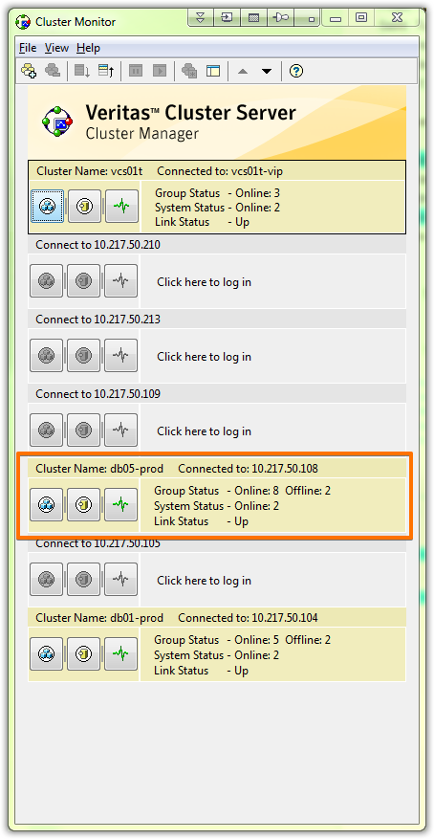

# 3. Freeze two databases.
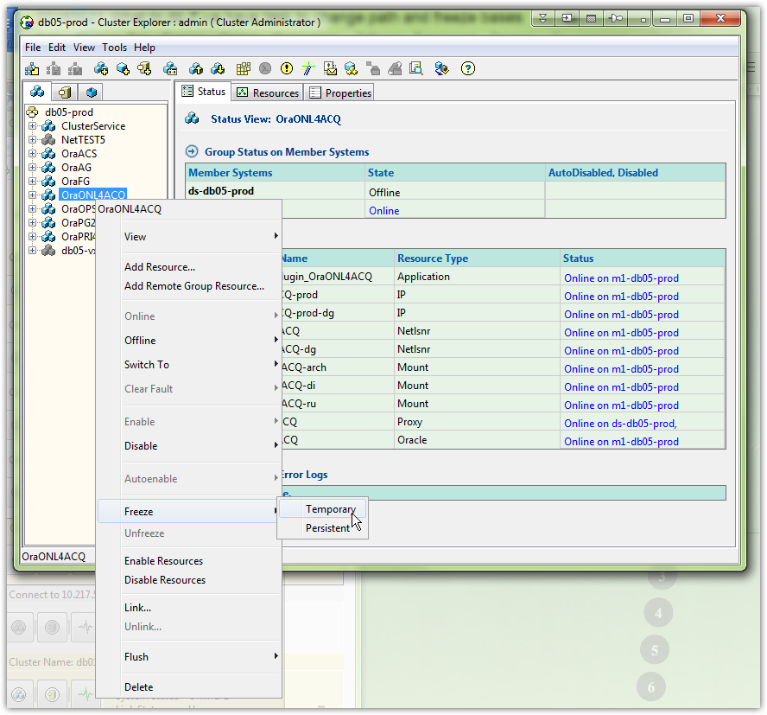

# 4. Change path to new one. There are 12 places, where path should be changed.
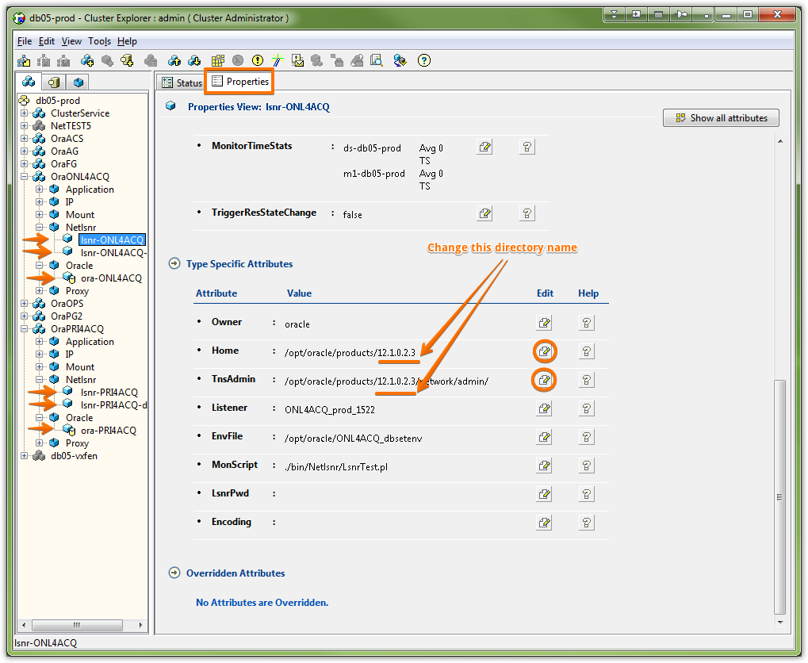

# 5. Save changes.
# This example was taken from test veritas cluster.
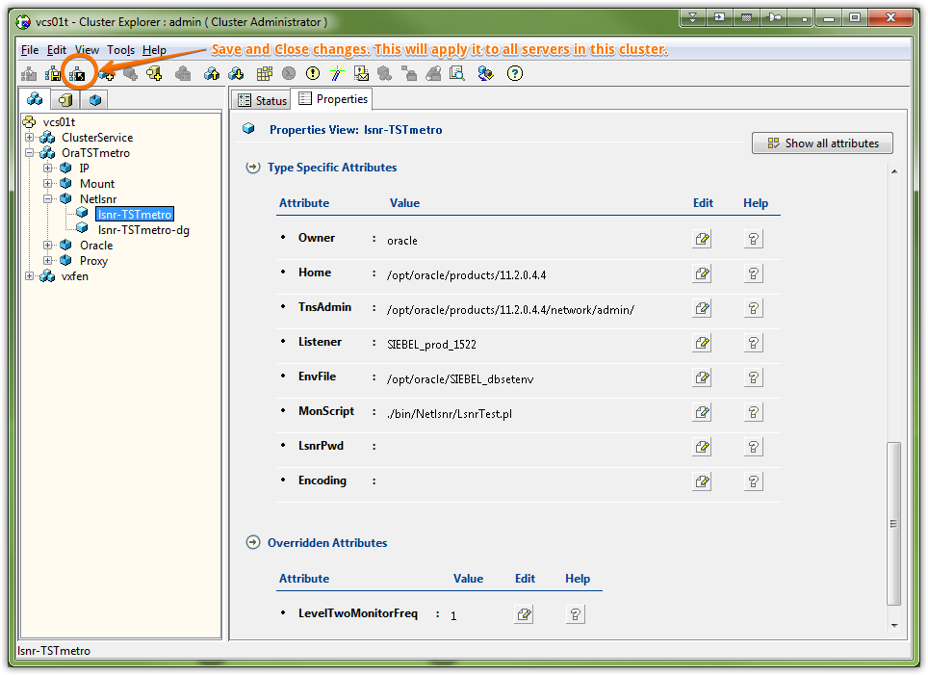

# 6. If every pictograms looks blue (without red signs) - this database can be unfreezed.
# This is very important point. All rows and pictogramms must looks healthy. Instead after unfreezing - database will start moving by veritas cluster to other server - and that’s not what we want, at all.
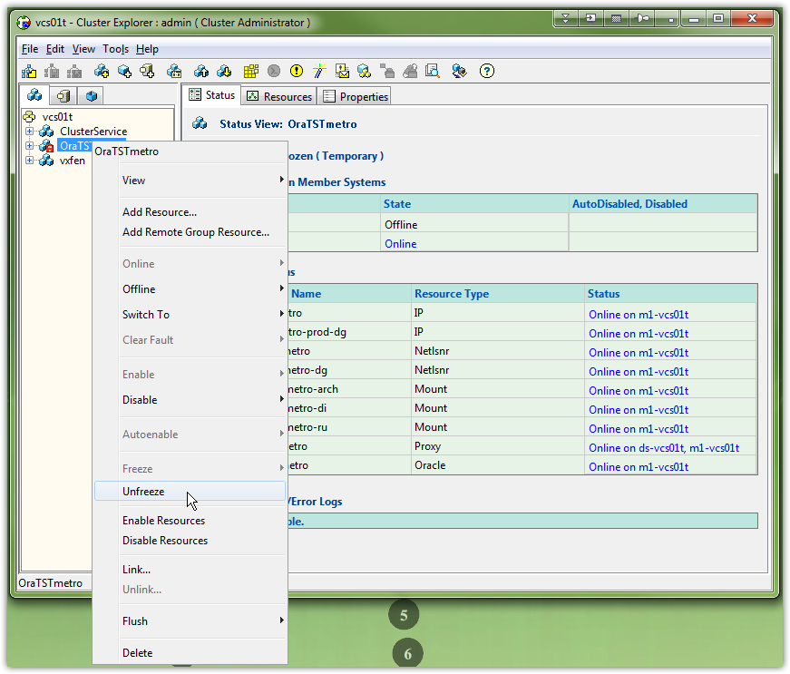

# Additional info.
# Logs could found here.
